**CSCI 1100 – Summer 2015**

**Laboratory Report 8**

**Name: Liam Gowan**

**Student ID:** B00673126

|  |  |  |
| --- | --- | --- |
| **Declaration: Please complete this declaration** | | |
| 1 | This document is entirely my own work. | Yes/no |
| 2 | I obtained help to complete this document (e.g., textbook, internet, friend, TA, instructor). | Yes/no. If ‘yes’ give Details. |
| 3 | This document contains some material copied or cut and pasted from the internet or another document or file or program. | Yes/no. If ‘yes’ give Details. |

**Exercise 1.** Define a method called calcArea that takes one parameter that is the radius of a circle. The method calculates and returns the area of the circle with that radius. For example the method call calcArea(10.0) returns the value 314.15.Test the method by calling it from the main method using input from the keyboard.

|  |
| --- |
| calcArea  double rad  double |

import java.util.Scanner;

public class Lab8Ex1 {

public static void main(String[] arg) {

Scanner keyboard = new Scanner(System.in);

System.out.println("Please type the radius: ");

double rad = keyboard.nextDouble();

}

// Define method here.

}

**I have modified the main method.**

**Program:**

import java.util.Scanner;

public class AreaOfCircle{

public static void main(String[] arg) {

Scanner keyboard = new Scanner(System.in);

System.out.print("Please type the radius: ");

double rad = keyboard.nextDouble();   
 double area = calcArea(rad); //calls calcArea() method, assigns to area  
 //Returns area with two decimal places  
 System.out.printf("The area of a circle with radius " + rad   
 + " is: %.2f", area);

}  
  
 public static double calcArea(double rad){  
 return (Math.PI * Math.pow(rad, 2)); //area = Pi*r^2, so it finds it  
 }  
}

**Test:**

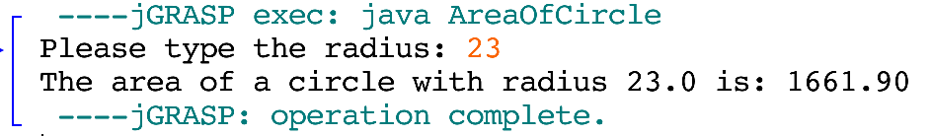

**Exercise 2.** Write a method called changeToCelsius (double g) that takes in a double representing the temperature in Fahrenheit. The method will convert the temperature to Celsius and will return it as a double. For example, changeToCelsius(94.5) will return the double (34.7222). When you print it to the screen, only show up to 2 decimal places. First draw a diagram representing the method (as shown in exercise 1.) If you don’t know the translate formula between Celsius and Fahrenheit, you can search it on google. Test the method by calling it from the main method using input from the keyboard. The program works as follows:

|  |
| --- |
| double tempInC  double tempInF  changeToCelsius |

**Program:**

import java.util.Scanner;  
  
public class TempConvert{  
 public static void main(String[] args){  
 Scanner input = new Scanner(System.in);  
 System.out.print("Please type a temperature in Fahrenheit: ");  
 double tempInF = input.nextDouble(); //Assigns tempInF to next double input  
 //Assigns tempInC to return value of changeToCelsius()  
 double tempInC = changeToCelsius(tempInF);   
 //Prints result up to two decimal places  
 System.out.printf("%.2f Fahrenheit is %.2f in Celsius", tempInF, tempInC);  
 }  
   
 public static double changeToCelsius(double g){  
 double tempInC = (g - 32) / 1.8; //calculates conversion  
 return tempInC;  
 }  
}

**Test:**

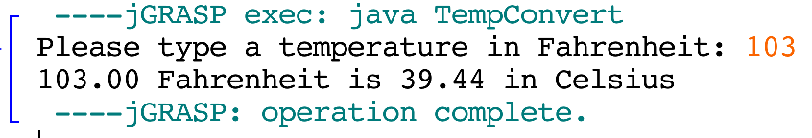

**Exercise 3.** Define and test a method called removeVowels that will read in a String and returns a new String with all the vowels (a, e, i, o, u) removed from the original String. The program treats lower and uppercase letters as equivalent. First draw a diagram representing the method (as shown in exercise 1.) Test the method by calling it from the main method using input from the keyboard. (Consider using String method: replaceAll to remove the vowels) The program works as follows:

|  |
| --- |
| String newString  String wordOrPhrase  removeVowels |

**Program:**

import java.util.Scanner;  
  
public class RemovalOfVowels{  
 public static void main(String[] args){  
 Scanner input = new Scanner(System.in);  
 String wordOrPhrase = "";  
 //prompts user for string, assigns to String variable  
 System.out.print("Type a string: ");  
 wordOrPhrase = input.nextLine();   
 //newString is equal to return value of removeVowels() method  
 String newString = removeVowels(wordOrPhrase);  
 //prints newString  
 System.out.println("New string: " + newString);  
 System.out.print("Thank you for using the system");  
 }  
   
 public static String removeVowels(String word){  
 String newString = "";  
 newString = word.replaceAll("[aeiou]", ""); //removes all vowels  
 return newString;  
 }  
}

**Test 1.**

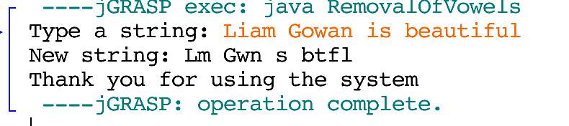

**Exercise 4.** Write a program that asks a user to enter in a number between 5 and 10. Create an array called nums that will hold that many numbers. The user will then input this many numbers that will be added to the array nums. Print out the contents of the array, the largest number in the array, and the average of all the numbers in the array. You do not need to create a method (you can write all the code in the main method). Try this out with 3 different input. The program works as follows:

**Program:**

import java.util.Scanner;  
  
public class NumberArray{  
 public static void main(String[] args){  
 int numLength;  
 Scanner input = new Scanner(System.in);  
   
 /*prompts user for number between 5 and 10, if it is not,  
 the while loops will asks user for another number */  
   
 System.out.print("Enter a number between 5 and 10: ");  
 numLength = input.nextInt();  
 while(numLength < 5 || numLength > 10){  
 System.out.print("Error: Number not between 5 and 10." +  
 "\nEnter a number that is: ");  
 numLength = input.nextInt();  
 }  
 //creates array called nums with length of numLength  
 int nums[] = new int[numLength];  
 System.out.print("Enter in " + numLength + " numbers: ");  
   
 //assings input to position in array  
 for(int i=0; i<numLength; i++)  
 nums[i] = input.nextInt();  
   
 //shows numbers in array  
 System.out.print("\nThe numbers in array nums are: ");  
 for(int i=0; i<numLength; i++)  
 System.out.print(nums[i] + " ");  
   
 //shows largest number in array  
 System.out.print("\nThe largest number is: ");  
 int largestNumber = 0;  
 for(int i = 0; i<numLength; i++){  
 if(largestNumber<nums[i])  
 largestNumber = nums[i];  
 if(i == numLength-1)  
 System.out.print(largestNumber);  
 }  
   
 //shows & calculates average of numbers in array  
 System.out.print("\nThe average of the numbers is: ");  
 double sum = 0;  
 for(int i = 0; i<numLength; i++){  
 sum += nums[i];  
 if(i == numLength-1){  
 double average = sum/numLength;  
 System.out.printf("%.1f", average);  
 }  
 }  
 }  
}

**Test 1.**

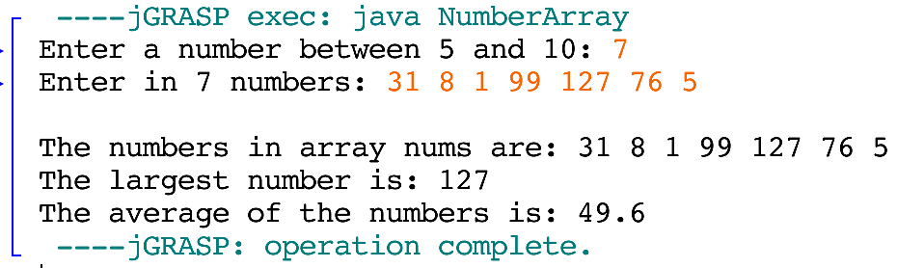

**Test 2.**

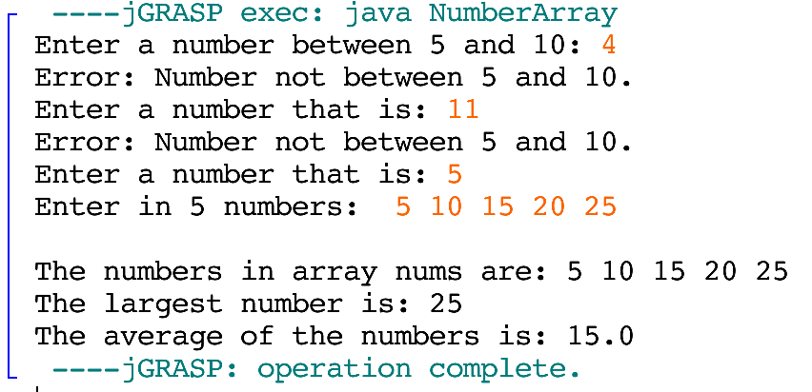

**Test 3.**

